

**INSTALLATION MANUAL**

### **Table of Contents**

### **Applicable Version**………………..….……………………………….……………………….………3

### **Prerequisite**..……………………………………………………….……………………………………….4

### **Installation**....………………………….……….………………………………………………………….5

### **Configuring Paynimo**……………………………………………………………………………………9

### **Applicable versions**

* PHP

1. PHP 7.1.x and above.

* Magento

1. Magento 1.7.x to 1.9.x

### **Prerequisite**

Make sure that following DLLs are enabled in PHP configuration file to work with Paynimo Payment Gateway:

extension = php_soap.dll

extension = php_openssl.dll

extension = php_curl.dll

**Installation**

Please follow the given steps to install and run the Paynimo Payment Gateway module

1. First, you need to log in to the Magento administrator area.
   1. Visit URL www.<mysite.com>/admin.
   2. Enter Username and password.
2. Then go to **System -> Magento Connect -> Magento Connect Manager**. 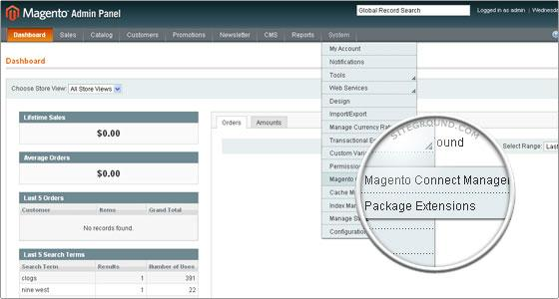
3. A new page will open for the Magento Connect Manager and you will be asked to provide your administrative credentials again.

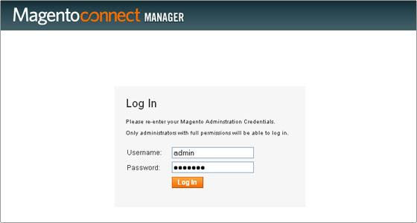

1. Once logged in you will see 2 sections: **Extensions** and **Settings**. It is recommended to verify the options chosen in the Settings section first.

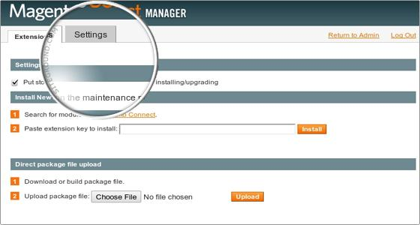

1. In the Settings section you can configure options if you need to do. It is safe to leave those options to their default values.

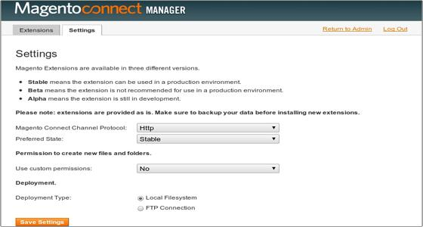

1. Go to **Extensions.** In “*Direct package file upload”* tab click on “*Browse*” button to upload package file. Select Paynimo.tgz file provided by Paynimo payment gateway module and click *open*. Now click “*upload*” to start uploading files.
2. Wait until you get message as “Package Installed”. The Console Box displays the results of your install. If there are any issues, it will be displayed in this box. After the extension is properly installed a screen for a successful installation will appear:

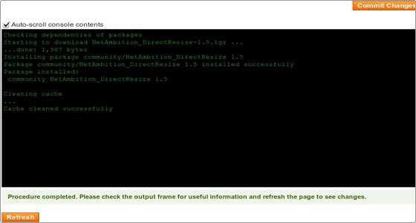

1. Click refresh. Once the extension is installed it is important to go back to Magento admin (Click on Return to admin).
2. Paynimo is now installed on your site.

**Configuring Paynimo**

1. Go-to admin panel.
2. Go-to menu System->Configuration.
3. Select “Payment methods” under “Sales” tab on left panel.
4. Click on Paynimo Payment Gateway.
5. Configure it as below:

| **Column Name** | **Description** |
| --- | --- |
| Enabled | “Yes” to enable and use, else “No” to disable paynimo |
| Title | Title Text to display during checkout process |
| IV | Enter IV. |
| Key | Enter Key. |
| Merchant Code | Enter merchant code. |
| Request Type | Select “T” for transaction request type. |
| New order status | Select as “Processing” |

1. Now click on “Save Config” on top- right corner.
2. Paynimo Payment Gateway is now configured & ready to use.